AOC 24E3QAF Disassembly SOP
Step | Figure | Description
Remove stand / base from monitor | 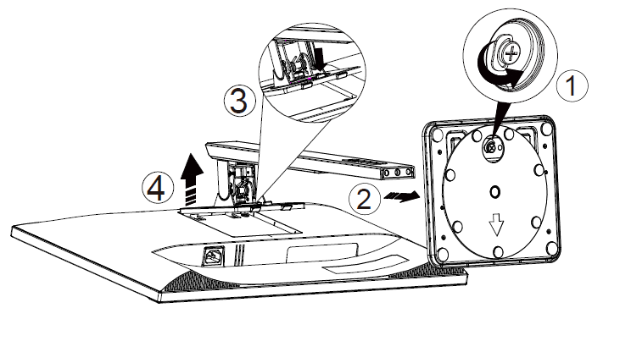 | - Place the monitor face down to the soft surface.  - Remove the screws  - Press release button to take out stand.
Remove back cover | 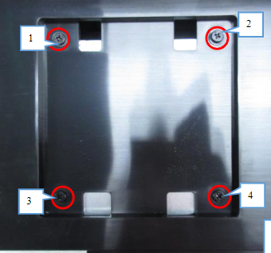  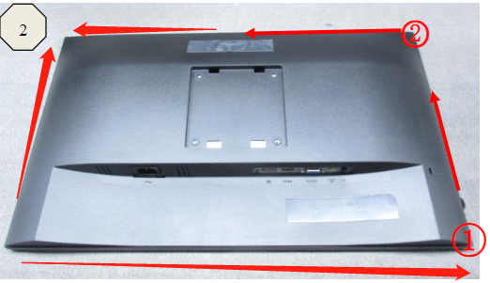  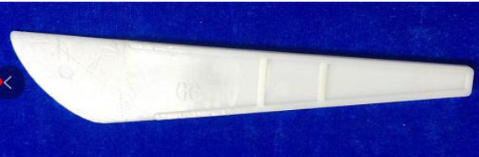  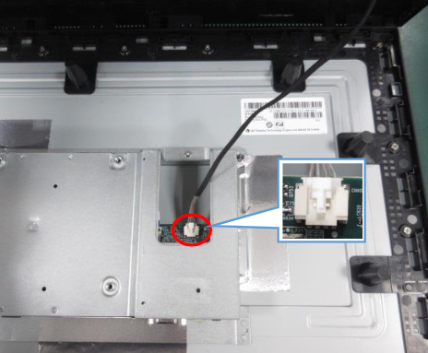 | - Release screws.  - Use tool to open all the latches.  - Disconnect cable to remove back cover.
Remove main frame | 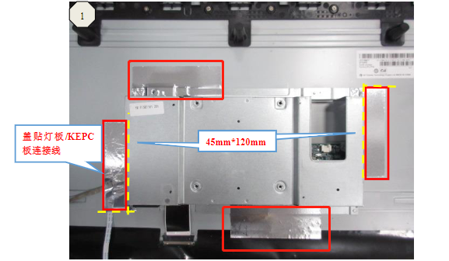  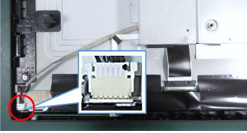  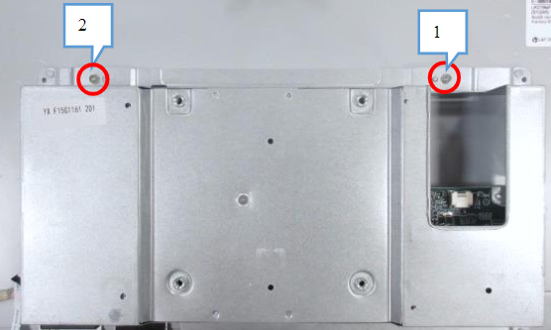  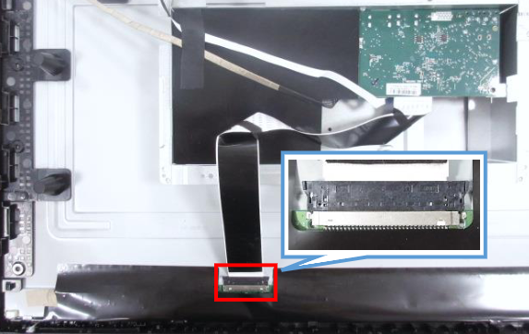 | - Tear out all the tapes  - Disconnect cable  - Release screw  - Lift up main frame to disconnect cable
Remove boards from main frame | 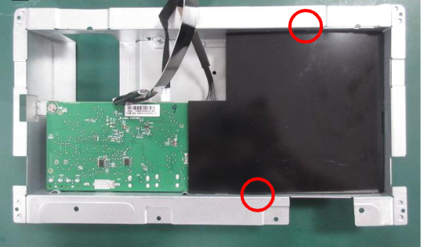  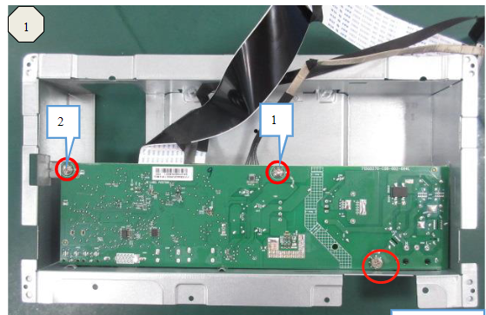  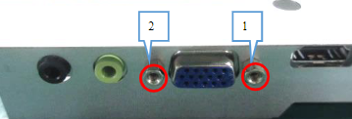 | Take out mylar  Release screws.
Take out middle frame | 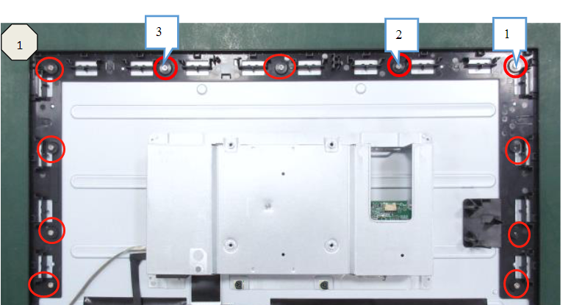 | Release screws.
Remove speakers | 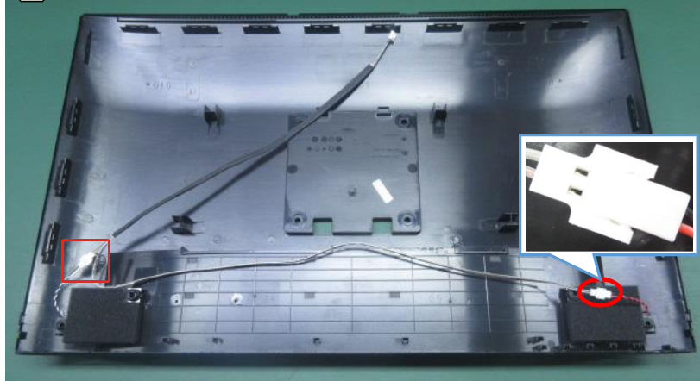 | Disconnect cables

