AOC GM530 Gaming Mouse
USER'S GUIDE Ver.:1.00

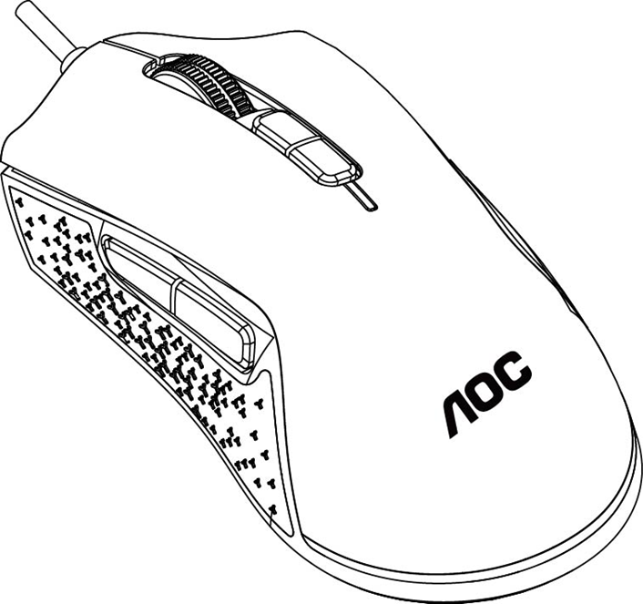

CAUTION: To use this product properly, please read the user's guide before installing.

Contents
1 Package Contents and System Requirements 3
2 Technical Specifications 3
3 Device Layout 4
4 Windows Installation 5
5 Open Methods 7
6 Software Update 8
7 Home 8
8 Device Setting 10
8.1 Mouse Settings 14
8.1.1 Customize 15
8.1.2 Sensitivity 18
8.1.3 Light FX 20
8.1.4 Light FX Sync 21
8.2 Macro 23
8.3 Discover 27
8.3.1 Download profile 29
8.3.2 Configure Profile 30
8.3.3 Upload 32
8.3.4 Search 33
8.3.5 Login 33
8.3.6 My Account 38
8.4 Setting 42
8.5 Tray 42
9 Safety Guide and Maintenance 43

1 Package Contents and System Requirements
Package Contents
- GM530 wired gaming mouse
- Quick setup guide
- Warranty card

Product Requirements
- Windows® 7 or above
- Available USB port

AOC G-Menu Requirements
- Windows® 7 or above
- 160MB free hard disk space
- Internet connection

Technical Support
- 2 years limited warranty
Free online technical support at www.aoc.com

2 Technical Specifications
Technical Specifications
- Advanced optical sensor with true 16,000 DPI
- Switchable DPI - 1200/1600/3200/6400/12000/16000 (default 1200 DPI)
- Up to 400 inches per second (IPS) and 50g acceleration
- 7 programmable buttons
- Kailh mechanical switch with up to 80 million clicks lifespan
- Up to 1000 Hz/1ms report rate
- 2 onboard memory profiles
- Customizable RGB lighting effect syncing with other AOC gaming devices
- 1.8 M braided cable
Approximate Size & Weight
- Length: 125 mm/ 4.92 in
- Width: 65 mm/ 2.56 in
- Height: 42m/ 1.65 in
- Weight: 100g/0.22 lbs
- Cable Length: 1.8 m/ 5.9 ft
Operating Environment
- Operating Temperature: 0 ° C (32 ° F) to 40 ° C (104 ° F)
- Operating Humidity: 10% - 85%

Device Layout
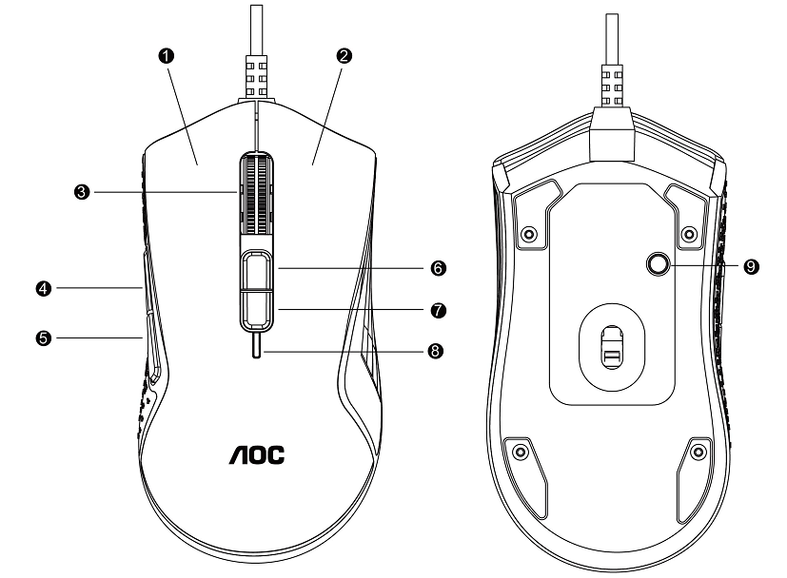
- Left Button
- Right Button
- Middle Button/Scroll Wheel
- Browser Forward
- Browser Backward
- DPI Up
- DPI Down
- DPI Indicator
- Profile Switch

4 Windows Installation
1. Download the AOC G-Menu executable, and double click the EXE file to start the installation.
2. Accept the license agreement by selecting the I Agree radio button, and clicking the Next button.
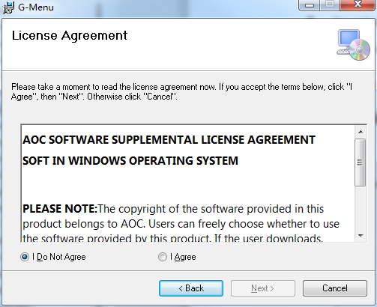
3. Select the installation folder. Select the default folder by pressing the Next button.
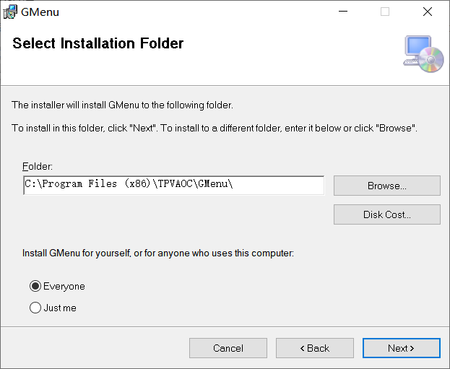
Selecting the Browse button will open a Browse for Folder dialog box.
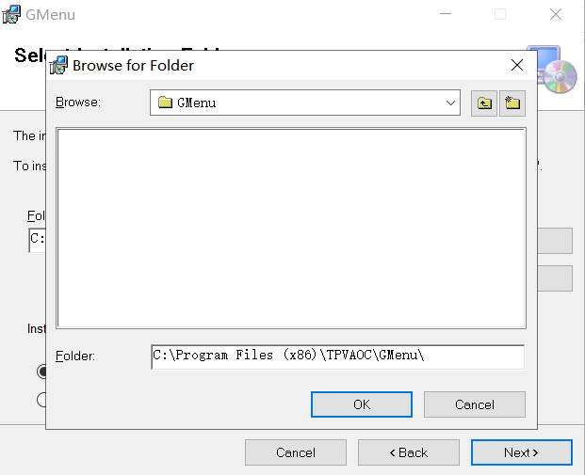
4. Confirm Installation by pressing the Next button.
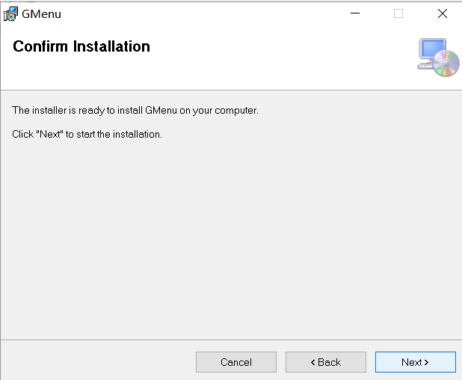
5. Complete the installation by pressing the Close button. Congratulations on installing G-menu!
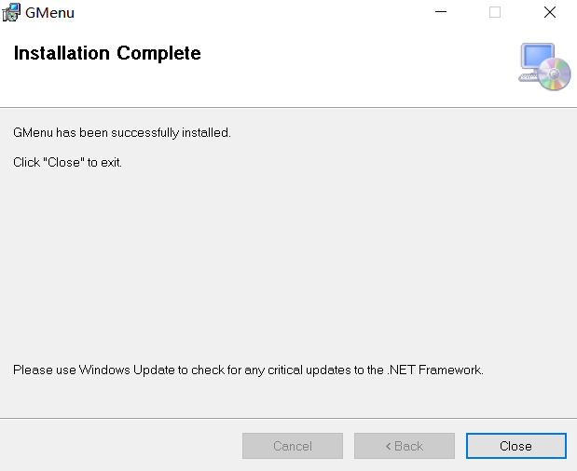
To uninstall G-Menu:
For Windows 10: Go to Windows Settings > Apps > Apps and Features > select G-Menu and press the Uninstall button.
For Windows 7/8/8.1: Go to Control Panel > Programs > Programs and Features > select G-Menu and press the Uninstall button.

5 Open Methods
There are 3 ways to access the G-Menu application.
- Start Menu>G-Menu
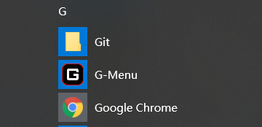
② Taskbar>Right click on the taskbar icon
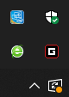
- Shortcut on Desktop
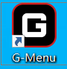

6 Software Update
- When you enter the G-Menu home page, the software will automatically check for updates, if there is a new version, it will be downloaded in the background.
- After the download is complete, the interface will alert you to install the update.
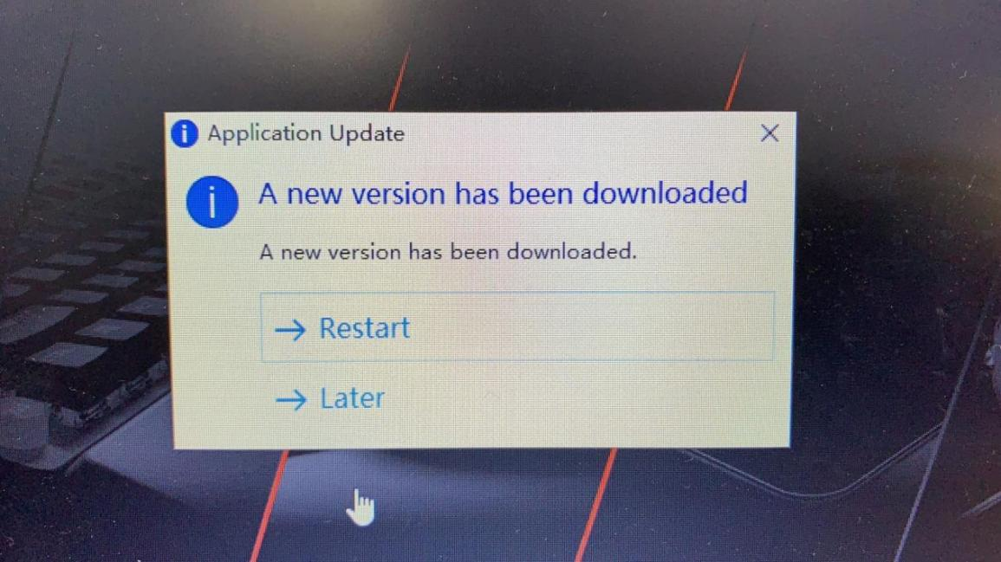
- Note: If there is no network connection, G-Menu will not be able to detect updates.

7 Home
- Open AOC G-Menu application and enter the home page.
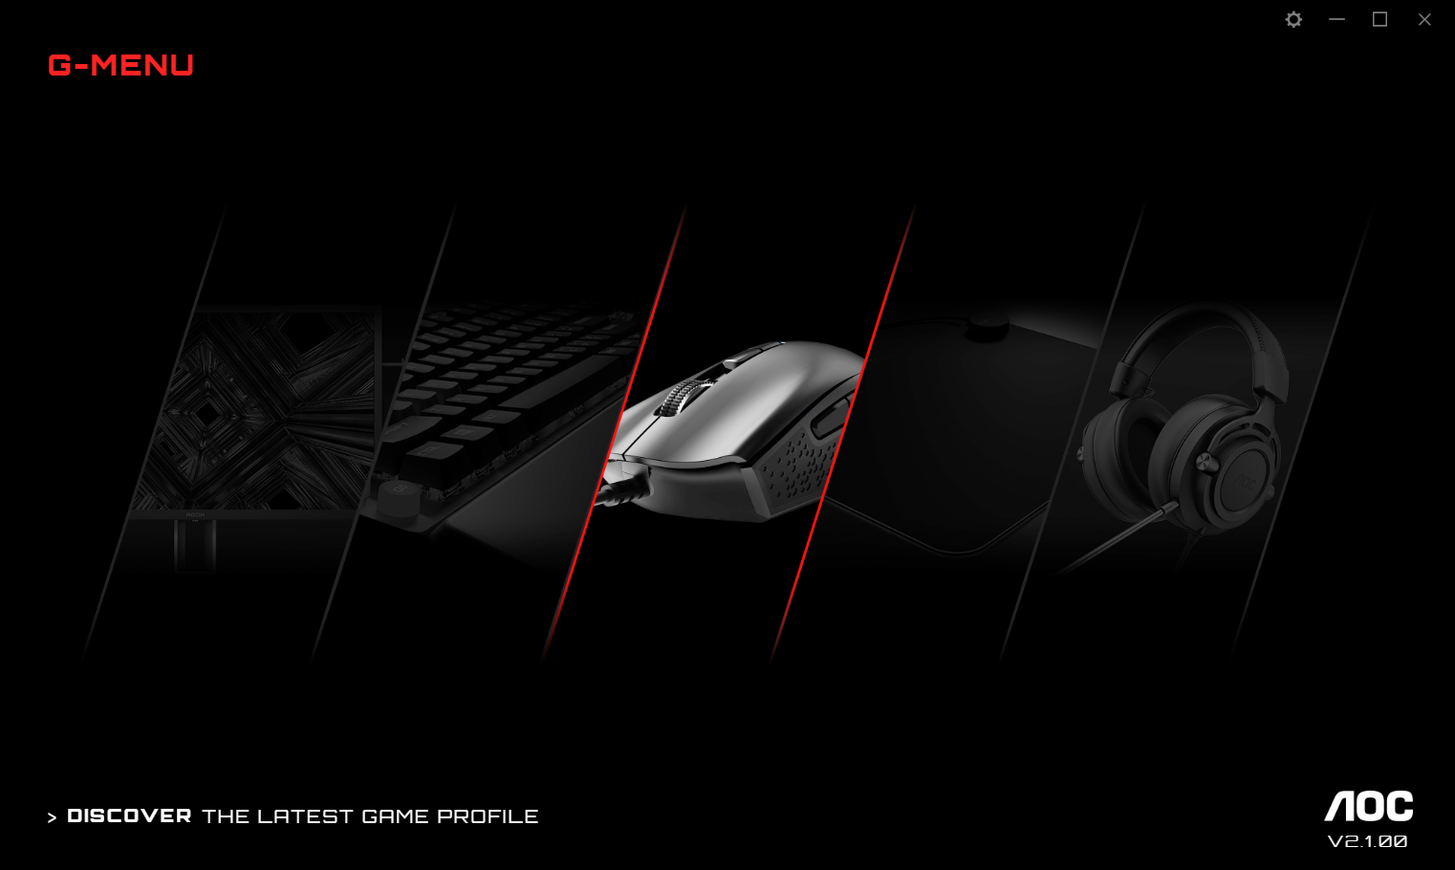
1） Application name: Displayed on the top left, not clickable.
2） Brand logo, Software version: Displayed at the bottom right, not clickable.
3） Minimize/Restore: Displayed at the top right. Click to switch the interface to zoom in/restore the display.
4） Setting: Displayed at the top right. Click to enter the setting interface, where you can set the language.
5） Device display:
- The device types supported by the current software are displayed by default, including: Monitor, Keyboard, Mouse, Mouse mat, and Headset.
- Currently connected devices are highlighted and may be clicked. Other device types are grayed out and cannot be clicked.
- Click on the device icon to enter the device settings interface.
6） Discover
- Click the Discover button to find the latest game profiles.
- Close: Click the Close button to close the application interface, the actual application is still running in the background.

8 Device Setting
- Top Navigation
- G-Menu navigation options: Home, Monitor, Mouse, Keyboard, Mouse mat, Headset, and Macro.
- The names of unconnected devices are greyed out.
- Click an active button to open the device settings interface.
- Click the Home button to return to the homepage.
- Left Navigation
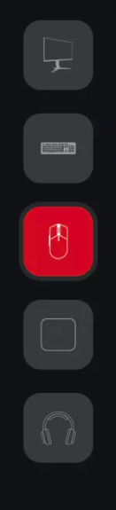
- Navigation button are, from top-to-bottom: Monitor, Keyboard, Mouse, Mouse mat, Headset.
- The icons of unconnected devices are hidden.
- Multi-model
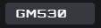
- Click on the Model drop-down menu to display a list of devices attached to the system.
- Data will start loading automatically after selecting a model.
- Select a profile
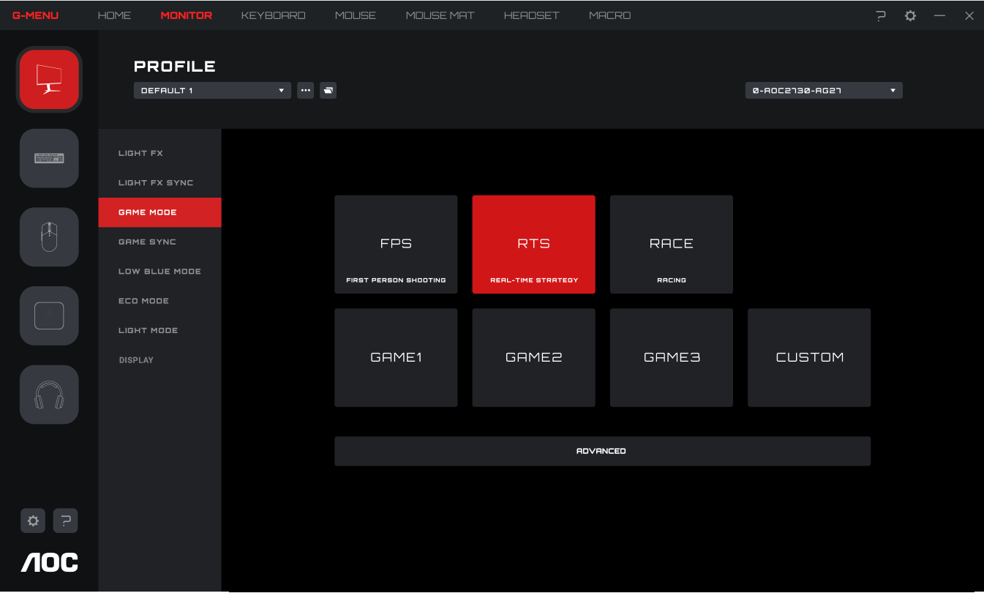
- Click on the Profile drop-down menu to display all local profiles.
- After switching the profile, it will be automatically configured on the current board and takes effect in real time.
5. More Profile Management
- Click the Meatball menu to expand the profile selection item: Add, Import, Export, Rename, and Associate.
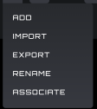
A) Add
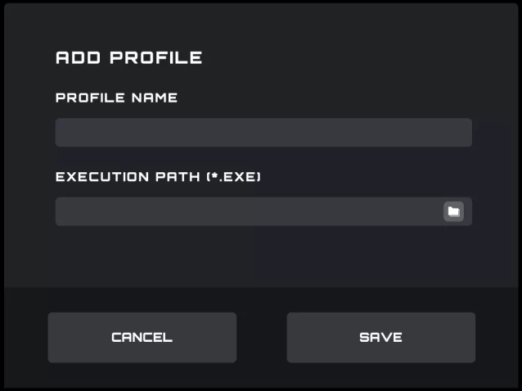
- Enter the name of the new profile.
- Click the File button to open the local executable file or enter the execution path in the input box directly.
- Click the Save button to add the profile.
- Click the Cancel button to close the pop-up box.
B) Import
- Opens a File Explorer dialog box.
- Locate the file to import and select it. Press the OK button to import the profile.
- The profile will be imported and populate the currently selected profile. The previous profile will be overwritten with the imported settings.
C) Export
- The export command will only export the settings for the current profile.
- A Save dialog box will open, and you may navigate to where you wish to save the file.
- Click the Save button to save the exported profile.
D) Rename
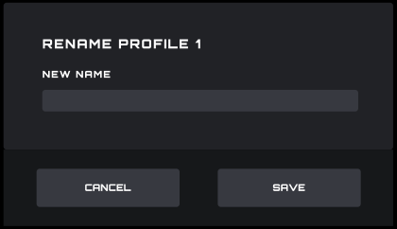
- Change the name of the current profile. It cannot be a duplicate of an existing profile name.
- Click the Save button to save the new name.
- Click the Cancel button to close the pop-up box.
E) Associate
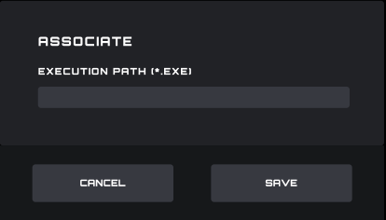
- You may associate an executable file to run each time the profile is selected.
- Click the File button to open a File Explorer dialog box that shows .exe files.
- Or you can directly enter the execution path in the input box.
- After selecting the application, click the Open button, the path will be automatically filled into the input box.
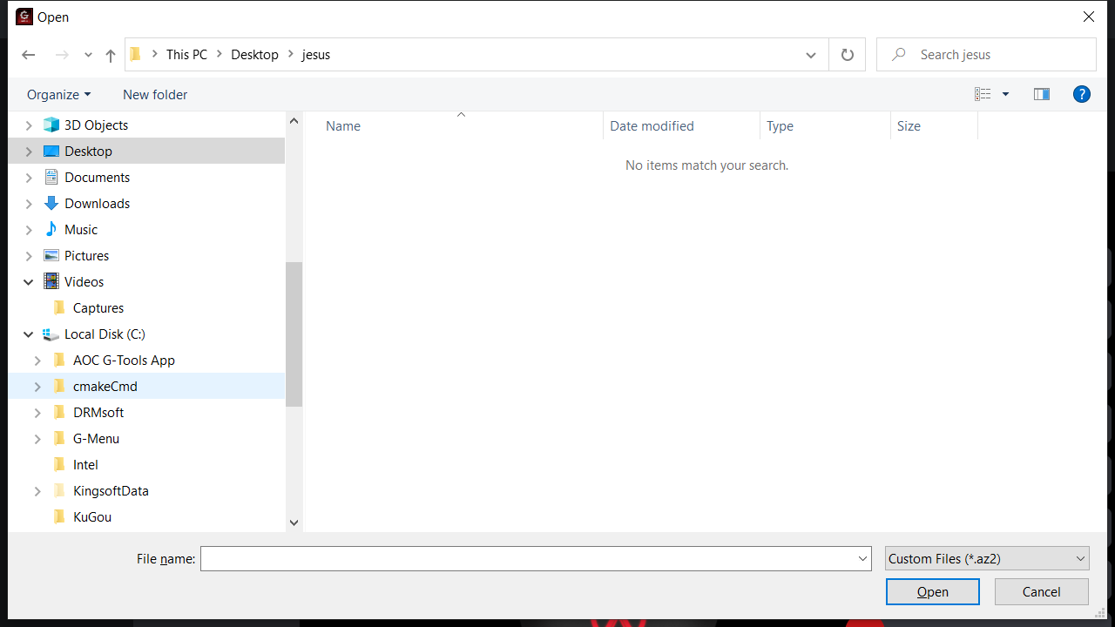
- Click the Save button to add the application to the profile.
- Click the Cancel button to close the pop-up box.
6. On board memory
Click the icon 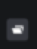 to open the On-Board Memory pop-up interface
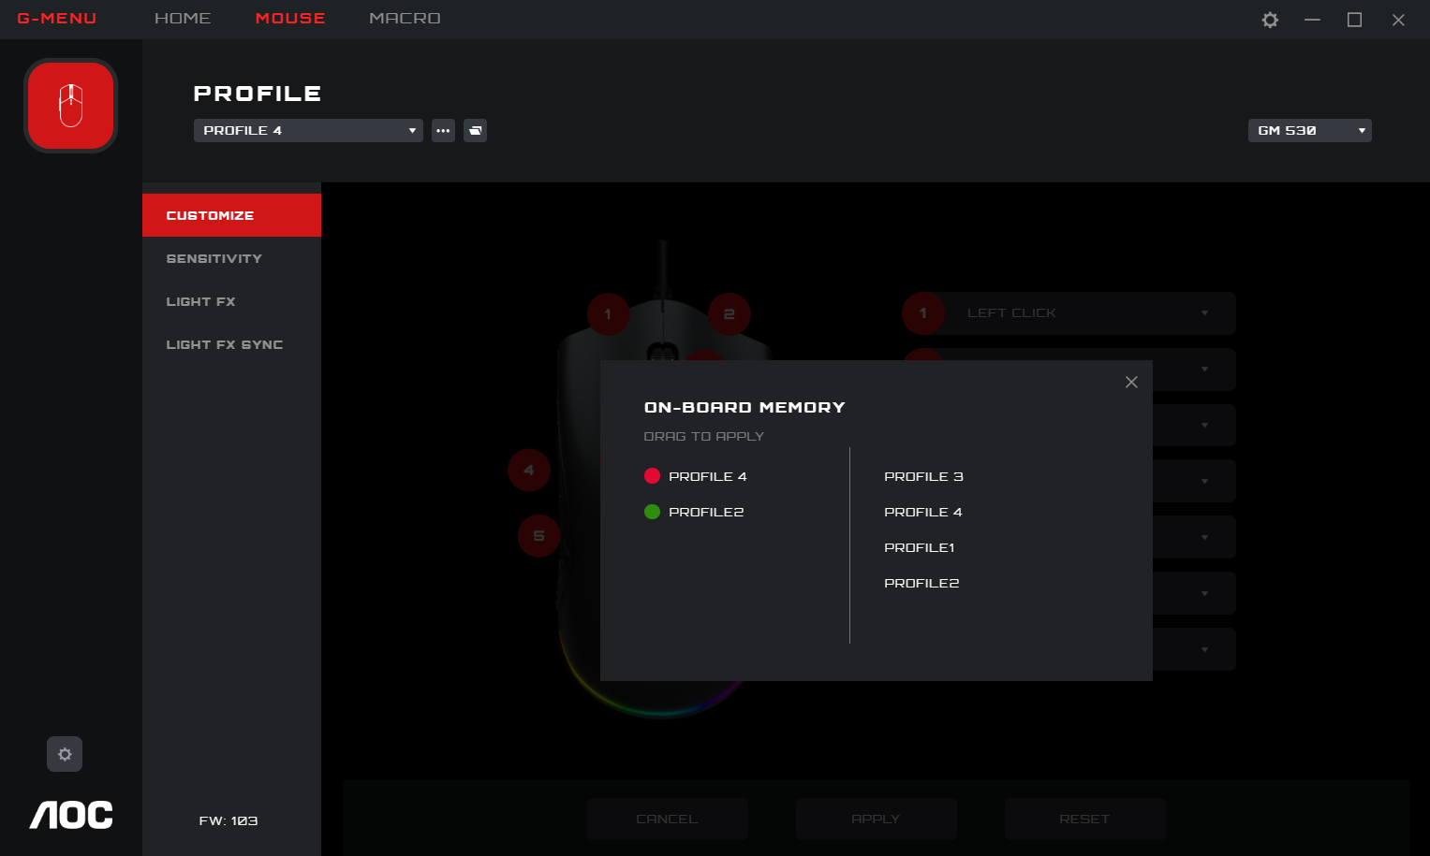
- The left side of the interface is the current device onboard, the right side is list of all local profile files.
- On-board adaptation: Drag the profile file to the back of the corresponding on-board color. After completion, the profile will be immediately applied to the on-board to take effect.
- Delete a profile
- Click the delete icon behind the profile to delete it.
- The profile currently in use does not support deletion.
- Click the close icon to close the pop-up window.

8.1 Mouse Settings
Prerequisites: Connect the mouse, and click the mouse icon on the home page.

8.1.1 Customize
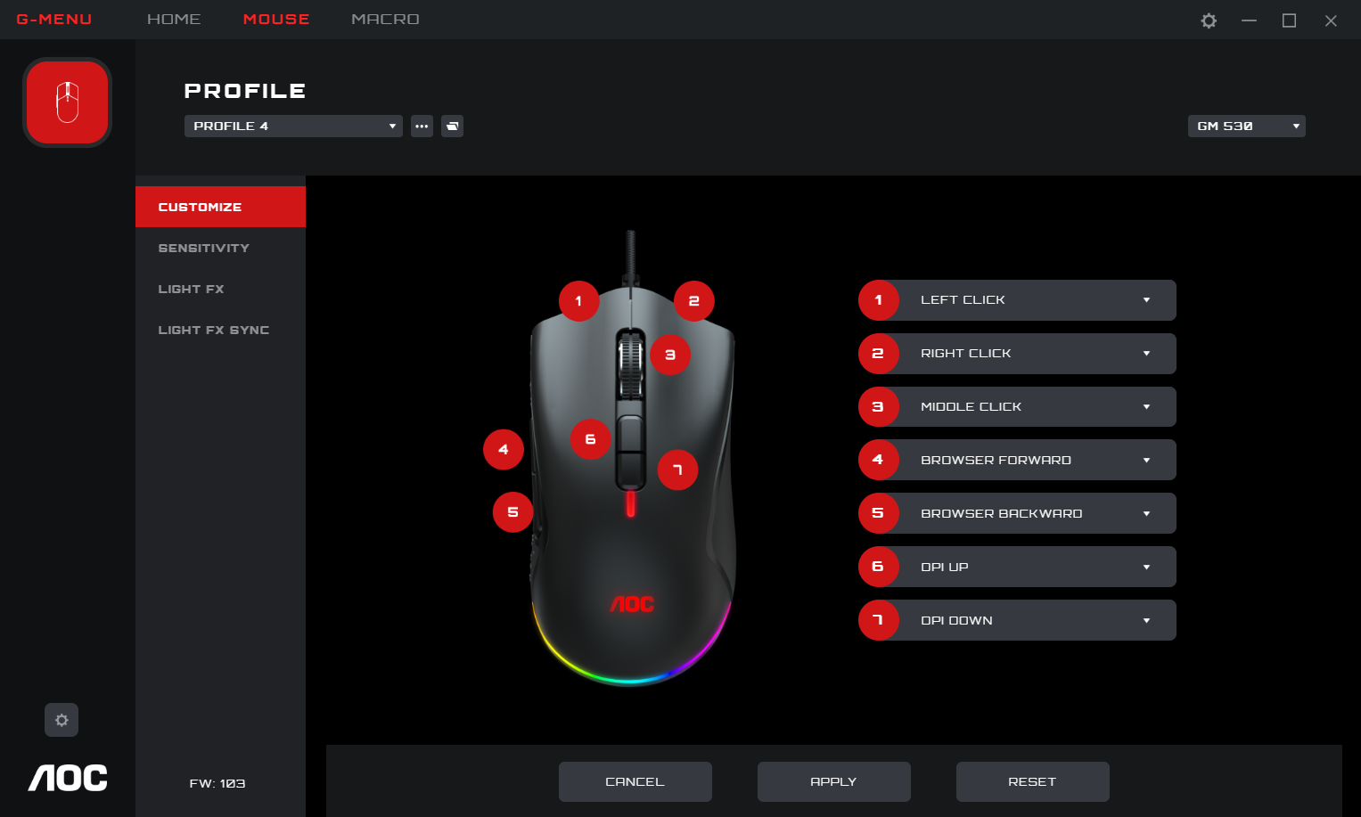
- Mouse
- Displays the currently connected mouse.
2. Key sequence number
- Not clickable.
3. Button definition
- Click the Mouse Button drop-down menu to display all key functions supported by the current device.
- Select the Macro Manager option to enter the Macro Select to use see 8.1.1.1.
- The button can be previewed immediately after the option is set; the option will only be maintained if the Save button is pressed before exiting the window.
- Note: There should be at least one left button function. If no button is defined as the left button function, the drop-down box of the button cannot be clicked to expand.
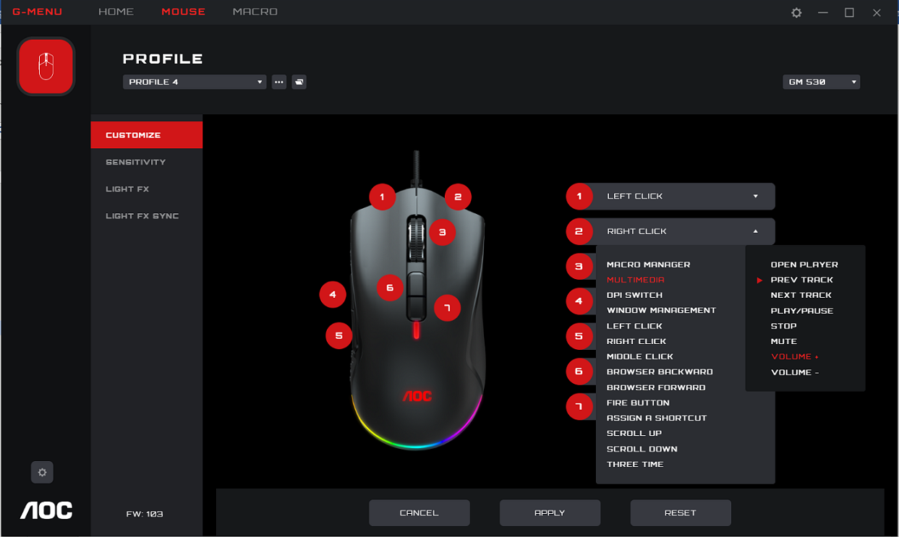
4. Cancel
- Click the Cancel button to cancel this mouse setting and revert to the previously saved state.
5. Apply
- Click the Apply button to save the current setting.
6. Reset to Factory Settings
- Click the Reset button, the dialog box is as follows:
  - Click the Cancel button to close the dialog box and cancel the reset.
  - Click the OK button to close the dialog box and restore the mouse profile settings to the factory default state.
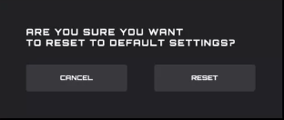

8.1.1.1 Macro select
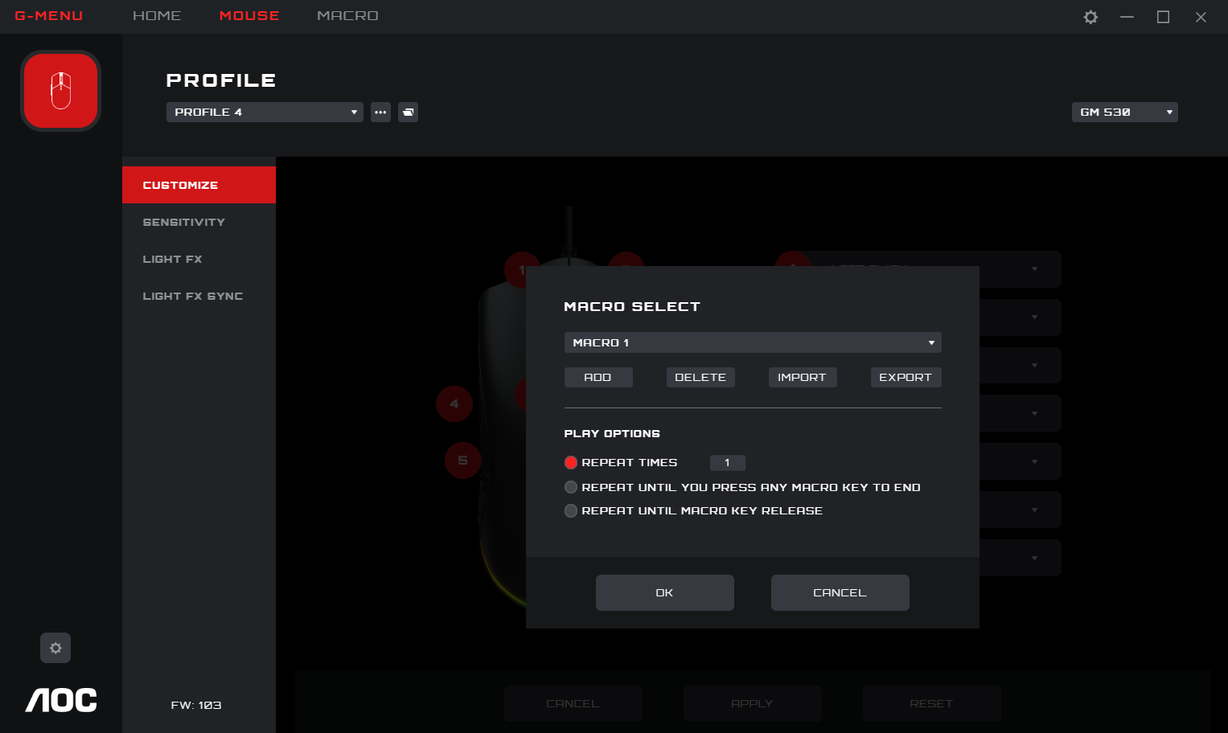
- Click the drop-down box to select an existing macro.
- Add
- Click the Add button to display the macro editing interface.
- Delete
- Click the Delete button to remove the currently selected macro.
4. Import
- Click the Import button to open a File Explorer dialog box, select the Macro file, and click the Open button to import the file.
5. Export
- Click the Export button to open the export file dialog to save locally.
6. Select Play Option
- After selecting a Macro play options are displayed at the bottom of the interface.
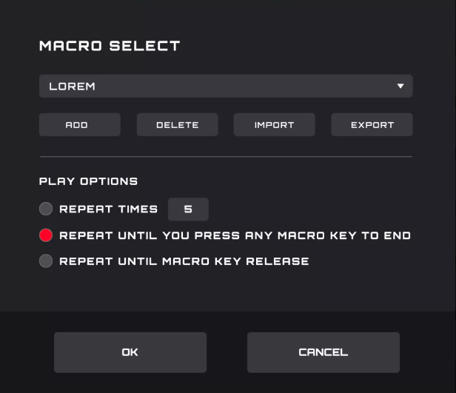
- Repeat Times: Enter the number of times to repeat the macro action, default 1.
- Repeat Until You Press Any Macro Key to End: Repeat the macro action until you press any macro key to end replay of the macro.
- Repeat Until Macro Key Release: Repeat the macro action only while the macro key is being pressed.
7. OK
- Click the OK button to enable the macro definition and play options.
8. Cancel
- Click the Cancel button to cancel the button macro definition and close the dialog box.

8.1.2 Sensitivity
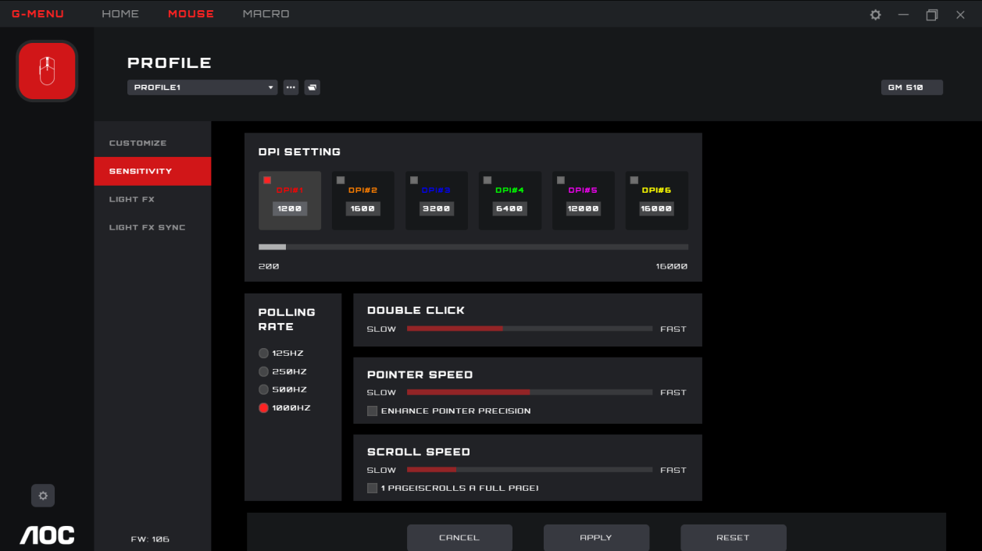
1. DPI Setting
- Each DPI setting has a corresponding color.
- DPI 1-6, click the icon to highlight, the input box and the slider below are activated.
- You can create up to 6 different settings. Change the setting with the slider from left to right.
  - The DPI setting can be different for each profile.
- The higher the DPI the more sensitive the mouse is to small movements, moving the cursor further across the screen.
- Polling Rate
- The option value comes from the device, the first one is selected by default.
- If the mouse is capable of different polling rates they will be displayed here. The first one will be selected by default.
- The higher the polling rate the more often the mouse updates its position. This consumes more CPU resources. Useful for small high precision movements.
- Double Click
- Adjust the time between registering two clicks as a double click.
- Pointer Speed
- Adjusts how fast the pointer moves across the screen.
- Enhance Pointer Precision: Enable this checkbox for Windows OS to provide additional acceleration for rapid mouse movement.
- Scroll Speed
- Adjust mouse wheel scroll speed.
- The 1 Page (Scrolls a Full Page) checkbox sets the mouse wheel to scroll entire pages.

8.1.3 Light FX
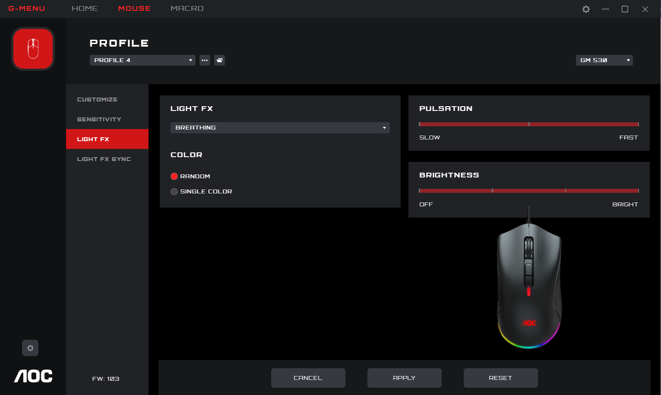
1. Light FX
- Click drop-down box to select a light effect.
2. Color
- Random: Let the computer select a random color.
- Single Color: open a palette to select or set a single color for the LEDs.
3. Single Color
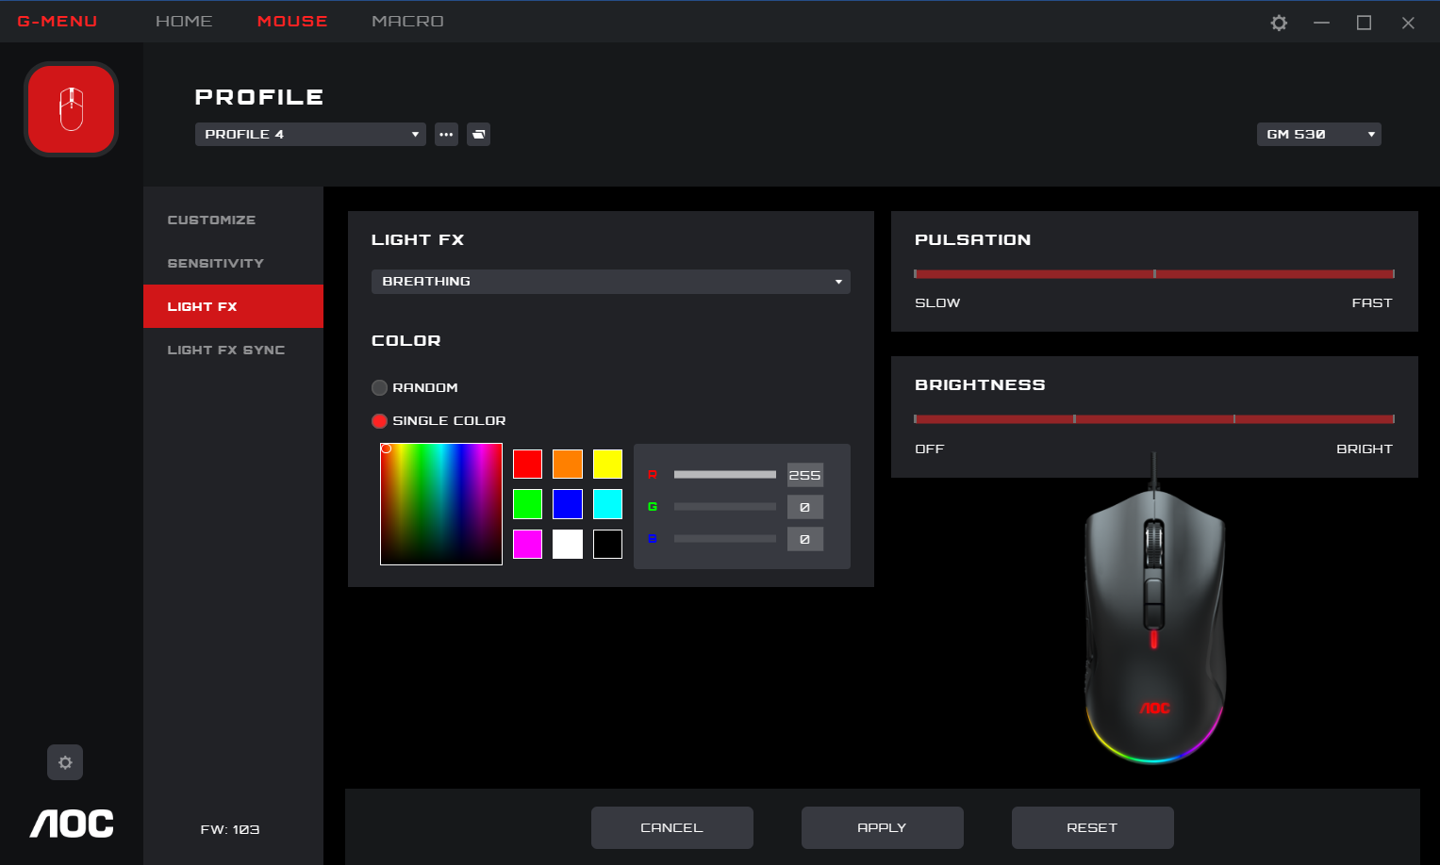
- A color can be selected from the color palette, color block, or a color can be defined by entering RGB values.
4. Pulsation
- Select how fast the color will change.
5. Brightness
- Select the brightness the color will glow or turn off.
6. Cancel
- Click the Cancel button to cancel this setting and return to the last saved state.
- Apply
- Click the Apply button to save this setting.
8. Reset
- Click the Reset button to restore the default factory settings.

8.1.4 Light FX Sync
Set the lighting effects across all currently connected devices. The last configured device will set all connected devices.
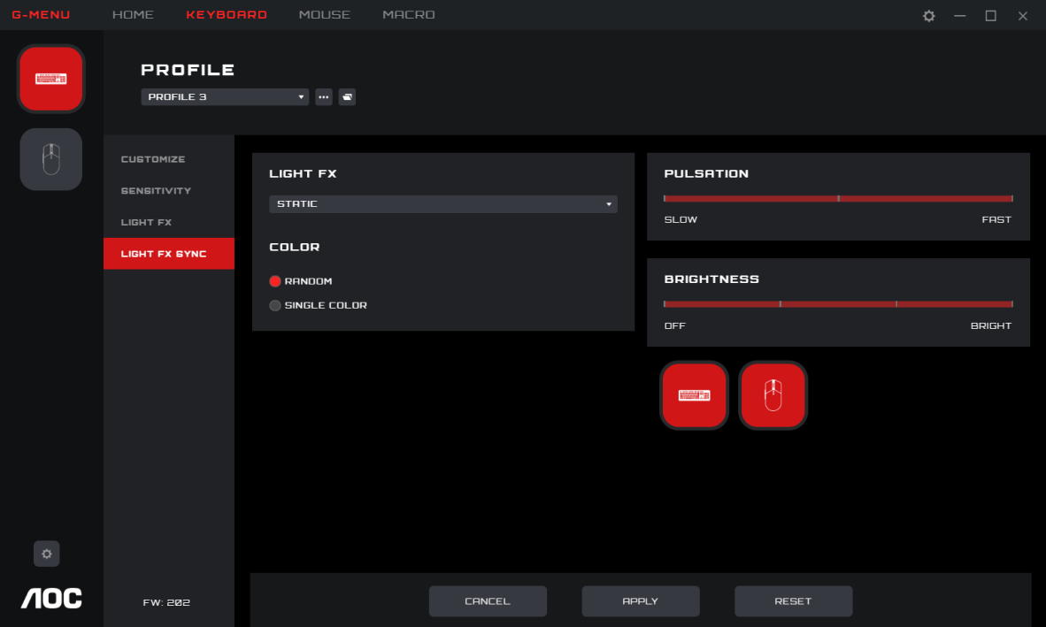
1. Light FX
- Click the Light FX drop-down menu to select a light effect.
2. Color
- Random: Let the computer select a random color.
- Single Color: open a palette to select a single color for the LEDs.
3. Single Color
- A color can be selected through a color palette or color block or a color can be defined by defining RGB values.
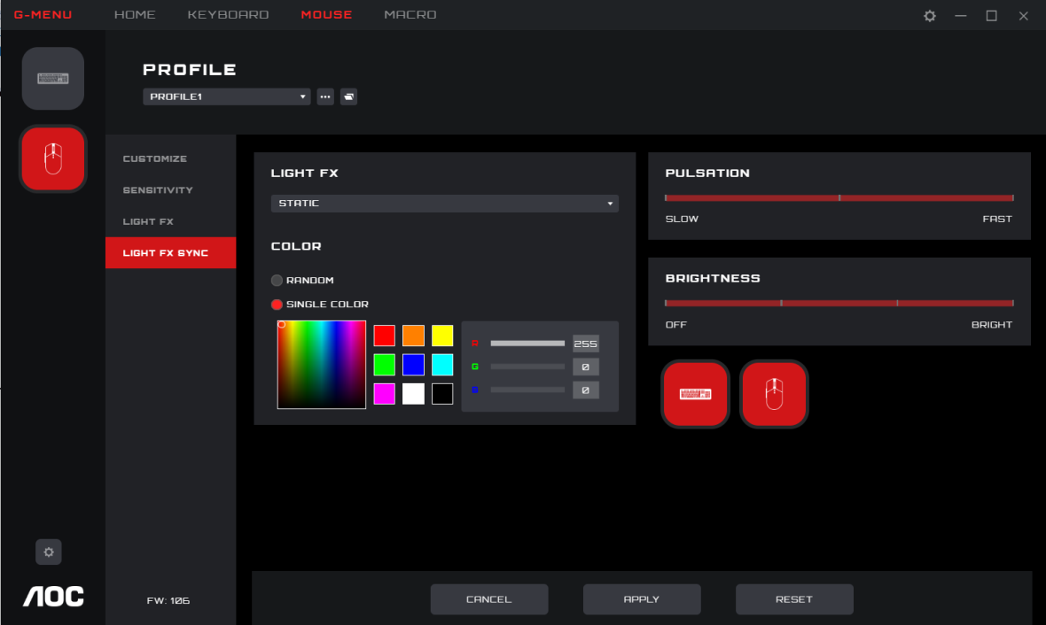
4. Pulsation
- Select how fast the color will change.
5. Brightness
- Select the brightness the color will glow or turn off.
6. Device
- Not clickable, the currently connected devices are highlighted.
7. Cancel
- Click the Cancel button to cancel this setting and return to the last saved state.
8. Apply
- Click the Apply button to save this setting.
9. Reset
- Click the Reset button to restore the default factory settings.

8.2 Macro
Create and edit macros from the Macro interface.
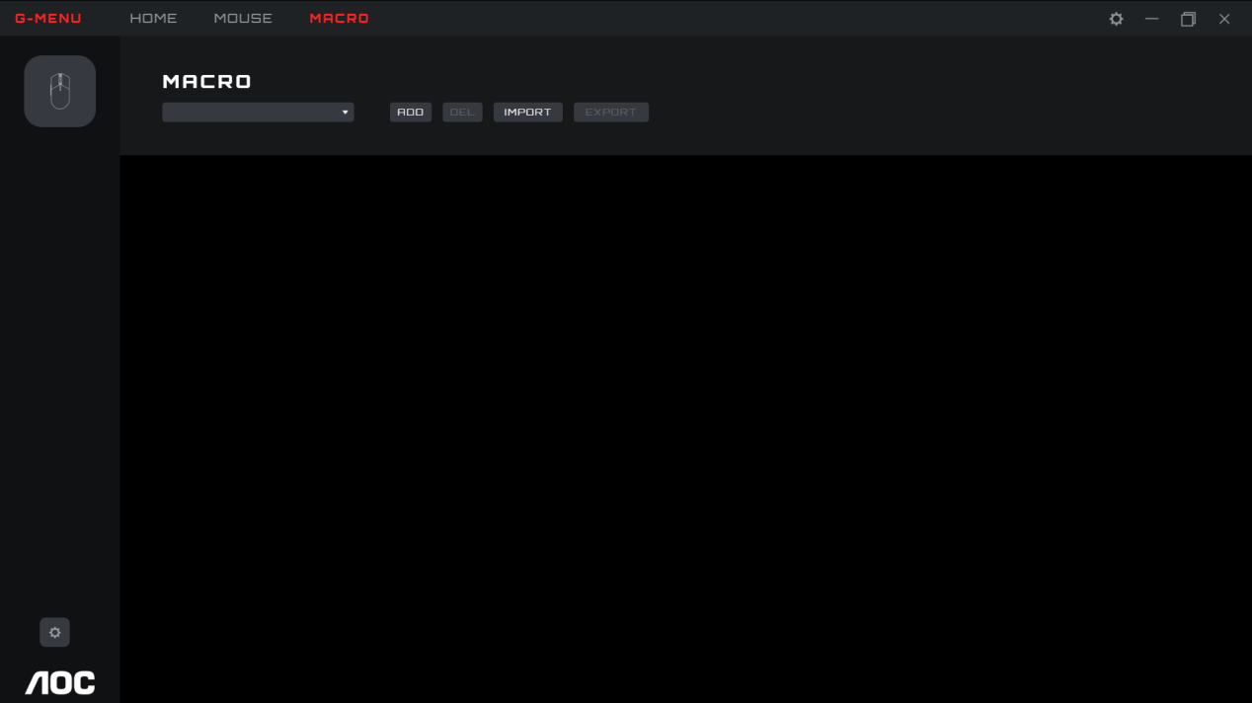
- Edit
- Select a macro from the drop-down menu.
- Add
- Click the Add button to display the macro editing interface.
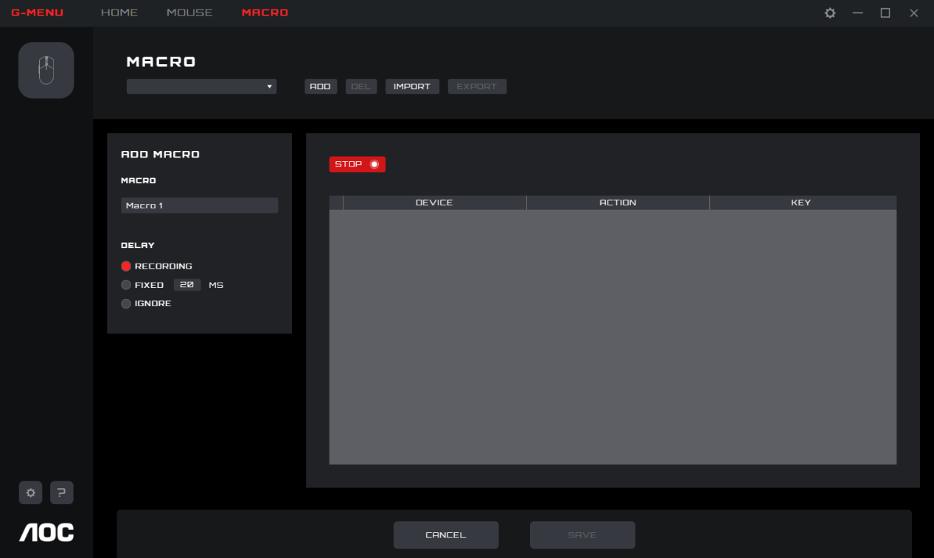
- Macro Name
- Enter a name into the text box. 50 characters max.
- Delay
- Select the delay time for running the macro.
- Recording: Follow the delays between actions exactly as recorded. Default.
- Fixed: The trigger time between each action is fixed. Default, 20ms.
- Ignore: Do each action in order, without delay.
- Start
- Click the Start button to begin recording a macro.
- If a macro exists, click the Clear button to remove the actions and begin a new recording.
- While recording, the Start button becomes a Stop button. During a recording, the macro setting options are disabled and only the keypress record box will be updated.
- Click the Stop button to finish recording.
- Keypress record
- Provides a real-time recording of all device keypress operations.
- Device: Show which device initiated the event, or the delay between events.
- Action: Registers Key down, key up and delay time events.
- Key: Which key was pressed or the duration of the delay time between events.
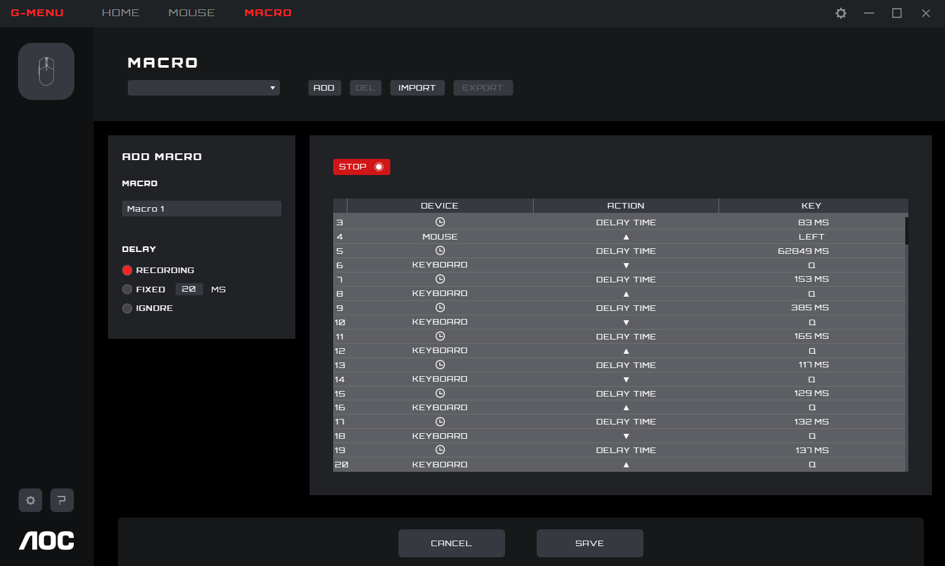
- Save
- Click the Save button to save the macro, making the macro editable.
- Cancel
- Click the Cancel button to cancel the macro creation process.
- Delete
- Click the Delete button to delete the macro. Then confirm or cancel the deletion.
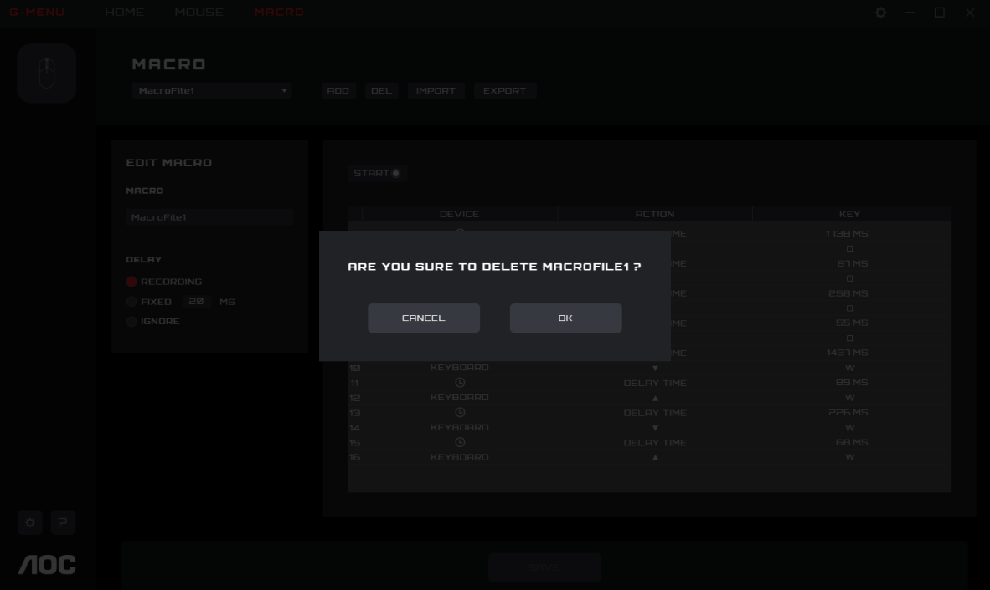
- Import
- Click the Import button to open a File Explorer dialog box.
  - Find the macro file to import.
  - Click the Open button to import the macro file.
  - Click the Cancel button to cancel the import, and close the dialog box.
- Export
- Click the Export button to open a Save As dialog box, the file name defaults to the current macro name.
- Navigate to your desired export folder.
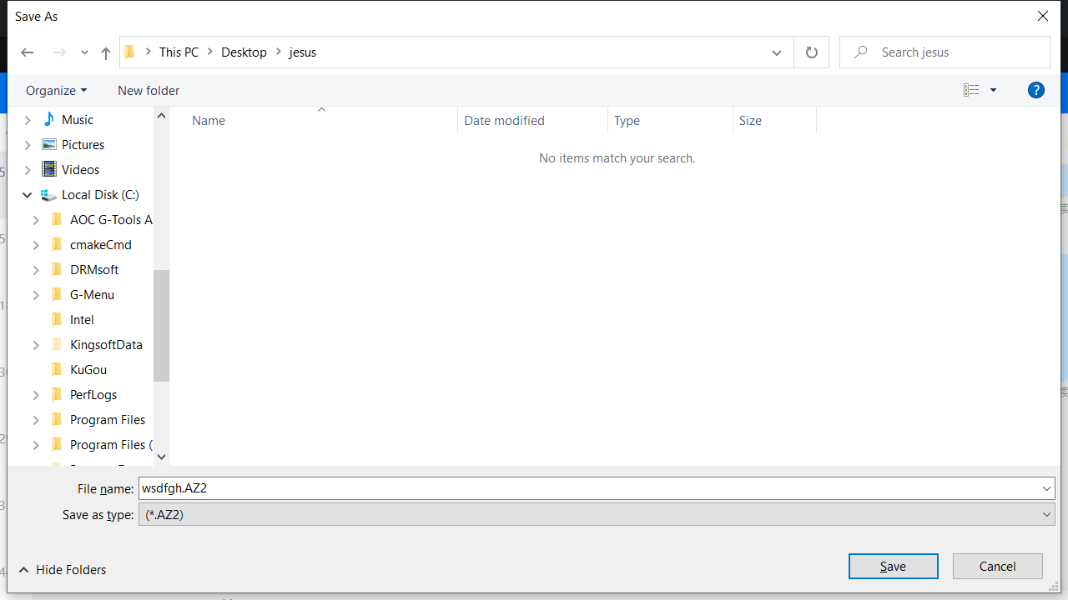
  - Click the Save button to export the macro file.
  - Click the Cancel button to cancel the export, and close the dialog box.

8.3 Discover
Discover and share profiles with others on the G-Menu network.
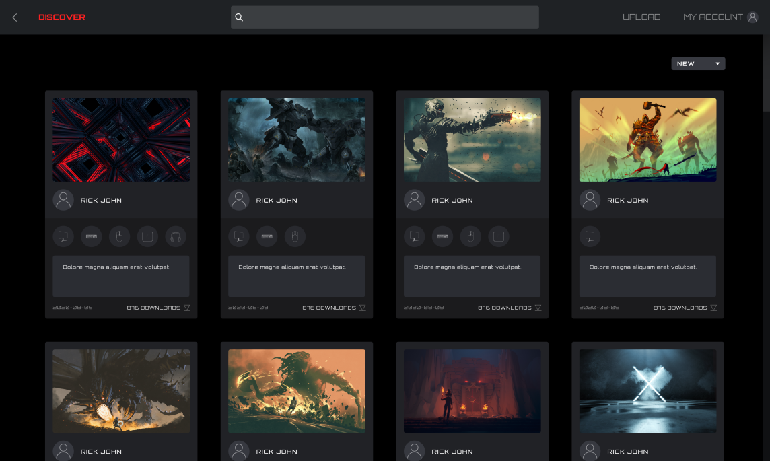
1. Back
- Click the < (Back) button to return to the main menu.
2. Discover
- Click the Discover button in the upper left corner to refresh the screen.
3. Search Bar
- Click in the Search bar to find profiles containing the search term in the publisher, title or description.
4. Upload
- Click on the Upload button to open the upload interface.
- If not logged in, the login interface opens.
5. My Account
- Displays the current account name and avatar. If the name is too long, it will be shown truncated with an ellipsis "...".
- If not logged in, enter the login credentials and click the Login button. See below for creating an account.
6 Profiles
- Select a sorting method from the drop-down menu:
  - Hot (default): Displays the most popular profiles.
  - New: Displays the newest profiles.
- Profile Details
  - Cover image: Each profile comes with a cover image.
  - Publisher name: The account that created and uploaded the profile.
  - Supported devices: Select the icon to reveal the supported model details.
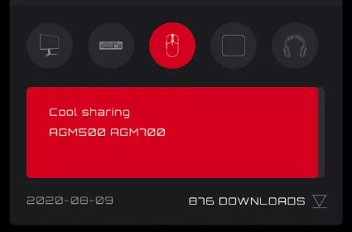
  - Profile Title and Introduction
    - The profile’s title and description, click on the ellipsis "..." for more information. Maximum 50 characters.
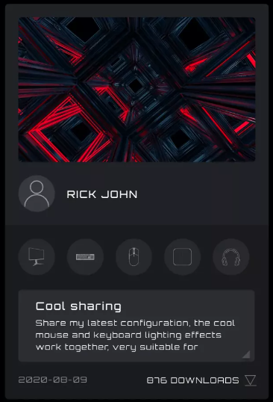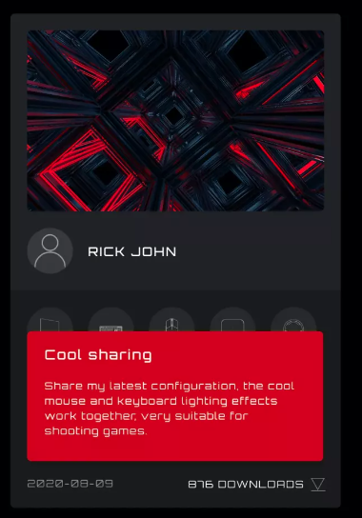
  - Upload Date: When the profile was uploaded, in year-month-day (yyyy-mm-dd) format.
  - Downloads: Shows how often the profile was downloaded.
  - Download Icon: Click on the Download button to download the profile.
  - Once the profile has been downloaded, the profile will be available for configuration. Click the Configure button to enter the configuration dialog box.
- Load a Profile
  - Double-click on a profile to load a profile for use.
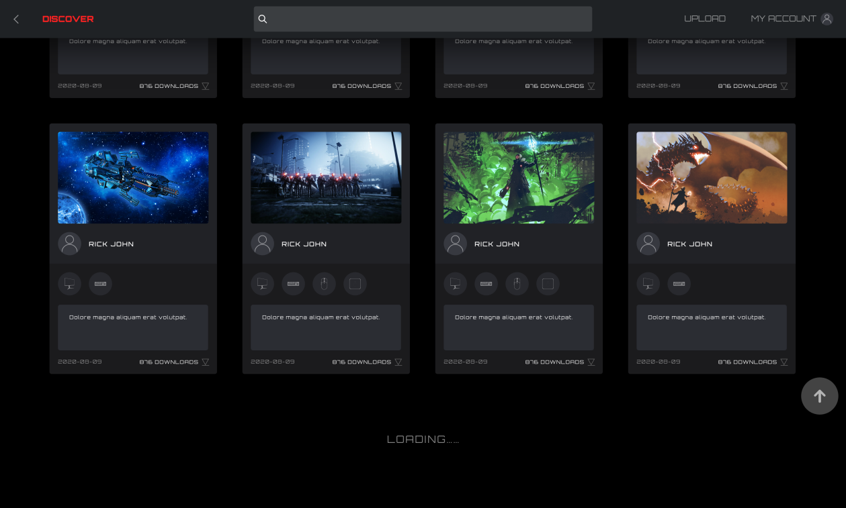
7. If the network cannot be reached the following error screen will appear.
- Click the Retry button to try connecting again.
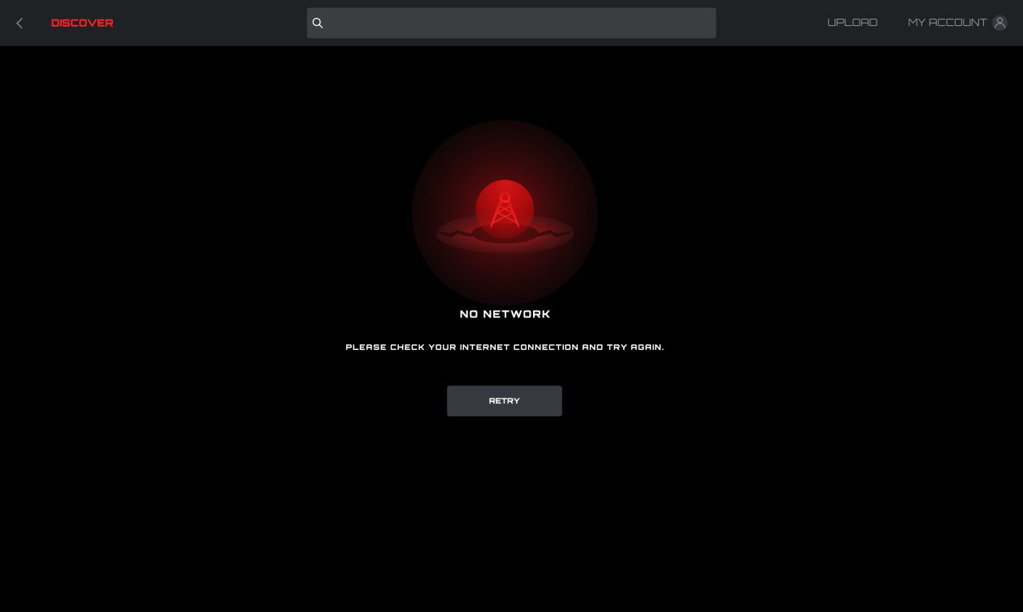

8.3.1 Download profile
- Click the Download button to start downloading the selected profile.
- This display will change to 'Downloading...'.
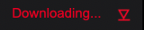
- After the download is complete.
- Click the Apply button to begin configuration.
- Click the Dismiss button to configure later.
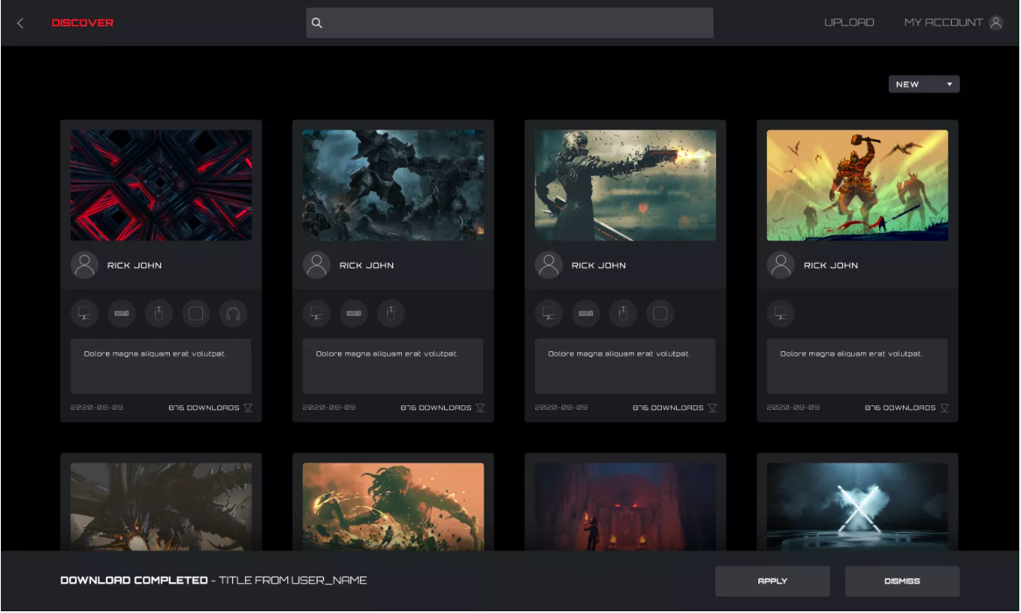
- Abnormal situation
- If the download is interrupted, the software will attempt to continue or you may re-download later.

8.3.2 Configure Profile
- When the profile download is complete, click the Apply button.
- Enter the Profile Configuration.
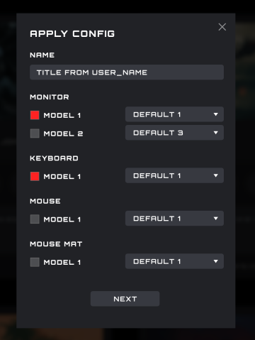
- If there is currently no compatible device available an error will appear.
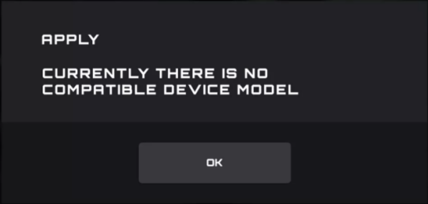
  - Click the OK button to close.
2. Configure
1) Name
- Enter a name for the configuration.
- Devices
- Select your specific device models.
3) Profile
- The current profile is displayed by default, and the selection cannot be switched.
4) Close
- Click the Close button to cancel the configuration.
5) Next
- Click the Next button to apply the current profile to your device(s).

8.3.3 Upload
Configure a profile and upload to share with others.
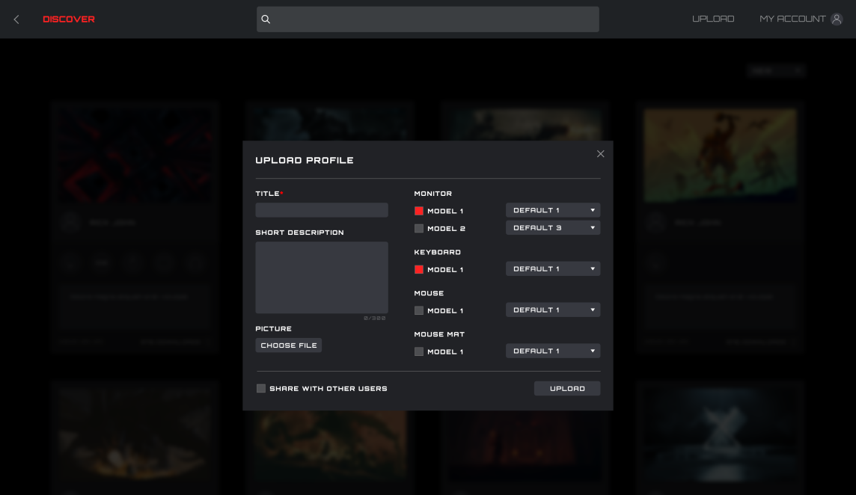
1. Title
- Enter a title. This is a required field.
- The number of input characters is limited to 50 characters.
2. Input short description
- Enter a description of the profile. The character limit is 300.
3. Picture
- Click the Choose File button to open a File Explorer dialog box to add a picture to the profile.
4. Monitor, Keyboard, Mouse, and Mouse Pad Models
- With the checkboxes, select the connected devices and device models for this profile.
5. Select a profile
- Select an existing profile to use with each device.
6. Share with Other Users
- Enabled: Shares this profile with the public.
- Disabled: Only visible in your My Upload screen.
7. Upload
- Click the Upload button to upload the profile.
8. Close
- Click the Close button to cancel upload.
9. After the upload is successful, the “Upload Successfully!” pop-up dialog box will appear.

8.3.4 Search
Prerequisite: Click the search bar
- Supports search of the publisher, profile name, and description text.

8.3.5 Login
Log into your account.
- When not logged in, you may also click on the Upload button to enter the login interface.
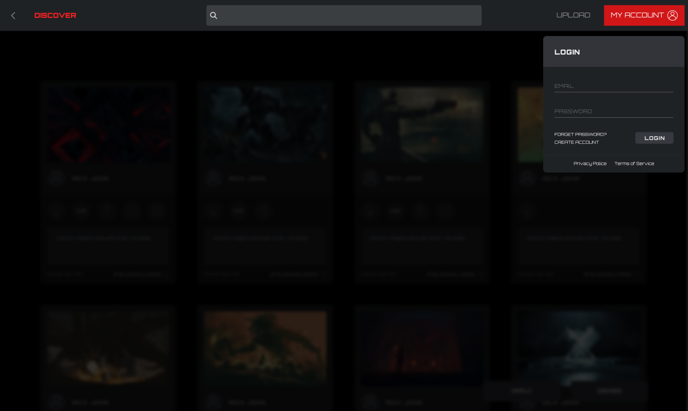
1. Email
  - Enter your Email address.
2. Password
  - Enter your password.
3. Login
- Click the Login button to log into your account.
4. Forgot Password
- Click the Forgot Password button to reset your password. For more information, see below.
5. Create Account.
- Click the Create Account button to create an account. For more information, see below.
6. Privacy Policy
- Click the Privacy Policy button to read the privacy policy for this software.
7. Terms of Service
- Click the Terms of Service button to read the Terms of Service for this software.
8. Back
- Click in the main window to dismiss the menu.

8.3.5.1 Create Account
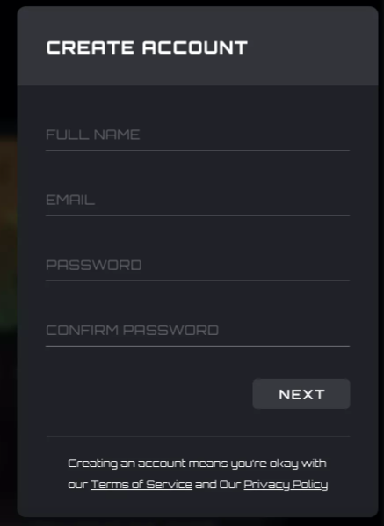
1. Full Name
- Enter your name.
2. Email
- Enter your email address.
3. Password and Confirm Password
- Enter and confirm a password. From 6-18 characters (letters, digits or special characters ).
4. Click the Next button to receive a verification code email. The code will expire in 15 minutes.
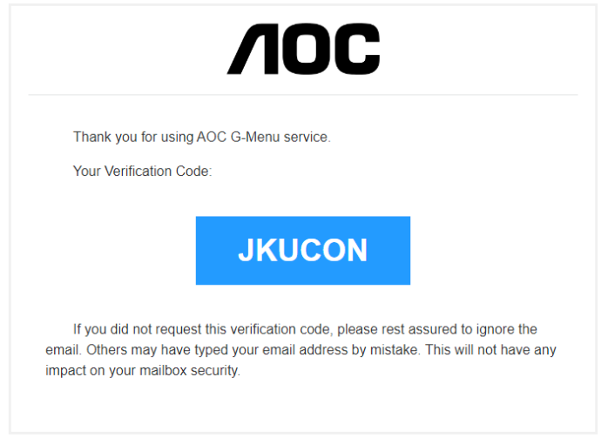
5. Verification code confirmation
- Enter the verification code you received.
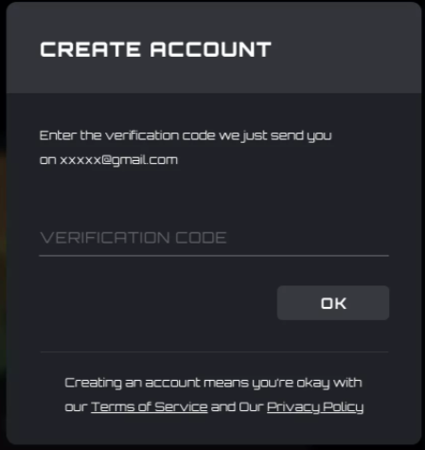
- Click the OK button:
  - If the verification code is correct, it will prompt that the account is created successfully, click the Login button to re-enter the account login interface.
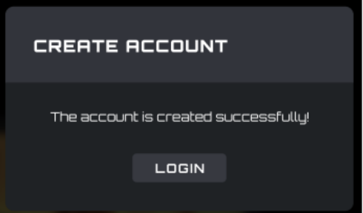
  - If the verification code is wrong, the error "The verification code is wrong" will appear.
  - If the verification code is expired, the error "Verification code has expired" will appear.

8.3.5.2 Forgot Password
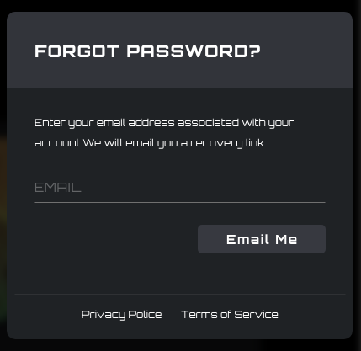
1. To reset your password: Enter the email address associated with your account. A recovery link will be sent.
2. Click the Email Me button to have the password reset email sent.
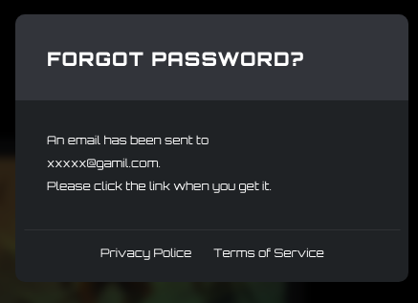
- Email password reset
1） Password reset link received in the email
- Click on the Reset Password button:
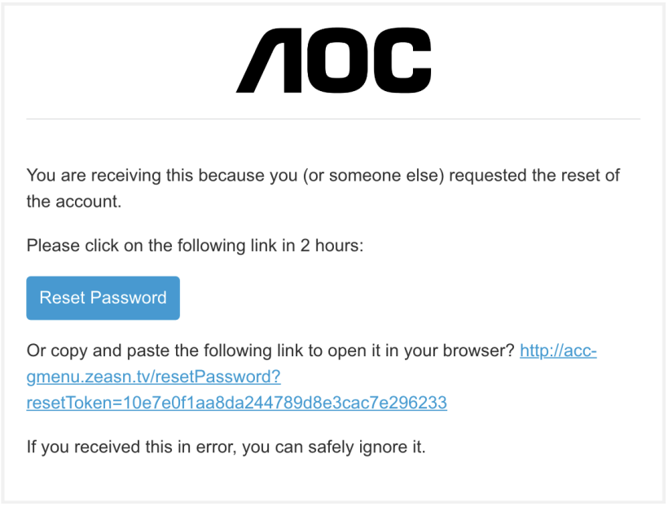
- Alternatively, copy and paste the link into your browser to open it there.
- Link valid time: 2 hours.
2） Password reset interface
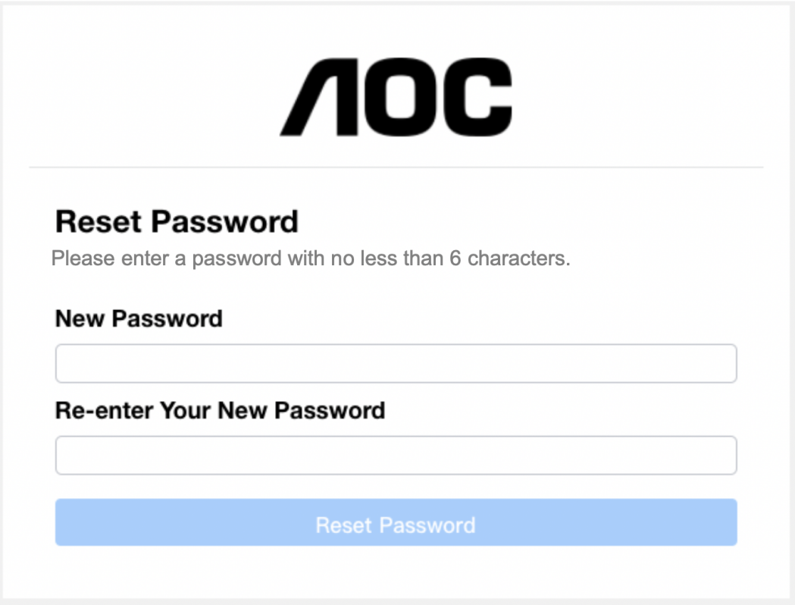
- Enter and confirm a password containing between 6 to 18 characters (numbers or letters).
- Click the Reset Password button:
  - If the passwords match and pass verification, the password is changes, and the success dialog box appears.
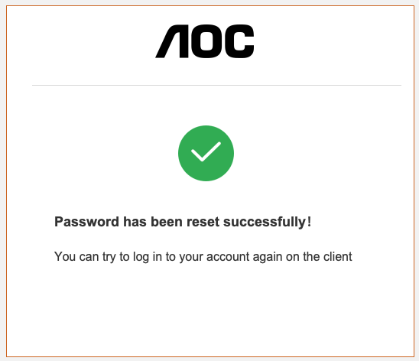
- Error message: The reset password link has expired
- The link sent in the email was not clicked on within the 2-hour reset period.
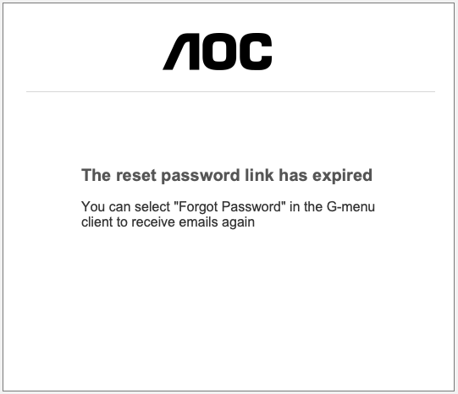

8.3.6 My Account
Prerequisite: You must be logged in to access your account information.
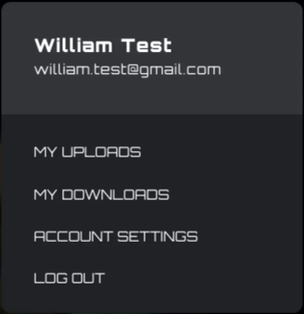
Click on the My Account button to display the account information.
- Account options:
- Click the My Uploads button to enter the My Uploads interface.
- Click the My Downloads button to enter the My Downloads interface.
- Click the Account Setting button to enter the Account Settings interface.
  - Click the Log out button to log the account out of the device.

8.3.6.1 My uploads
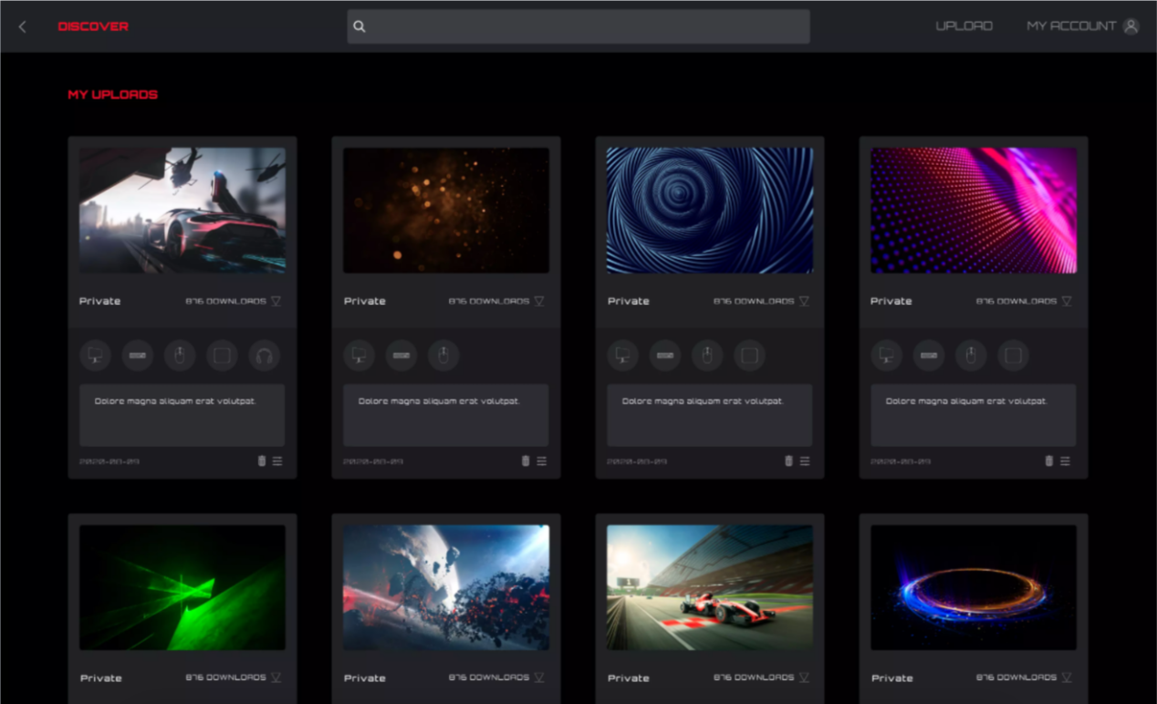
1. Click the Discover button to return to the discover homepage.
2. Click the Back button to return to the main menu.
3. Profile content:
- Cover
- Publisher's nickname and avatar
- Profile title and introduction
- Adaptation equipment and model
- Public/Private
- Release time
- Download (configure)/delete button
4. Click the Delete button to delete the Profile file from the discover screen.
5. Click the Upload button to upload a profile.
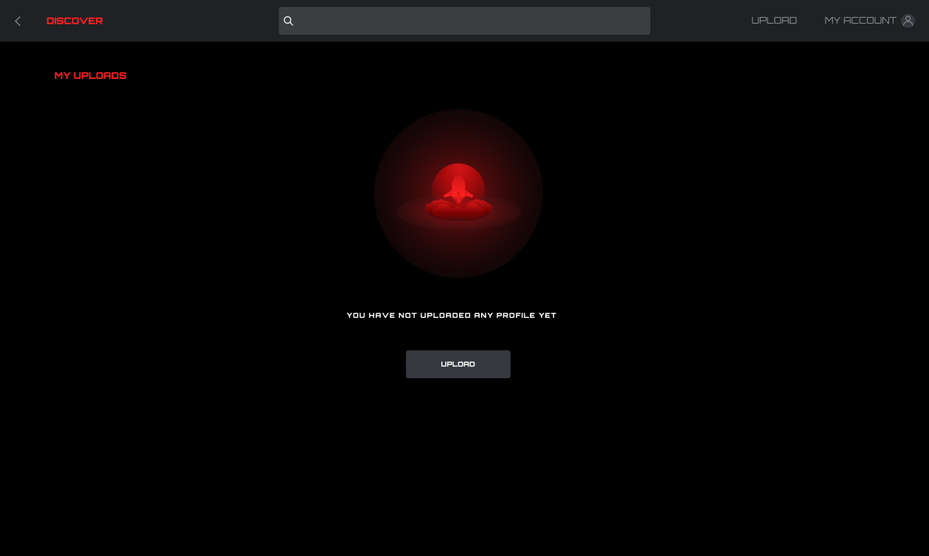

8.3.6.2 My downloads
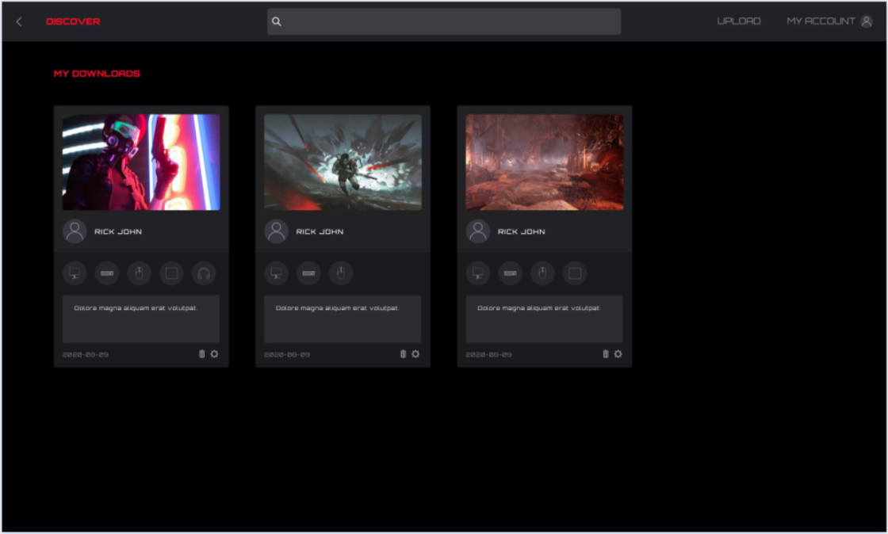
1. Display the profile information and download time of profiles that have been downloaded and saved locally.
2. Click the Configuration button to enter the configuration interface.
3. Click the Delete button to delete the profile file locally and return to the Profile list.

8.3.6.3 Account settings
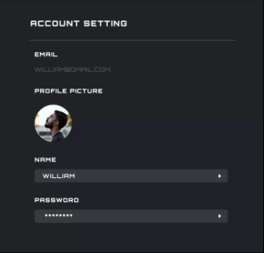
- The Email address cannot be changed, to change the email address create a new account.
- Profile picture
- Click to open a File Explorer dialog box to change the picture.
- Edit Name
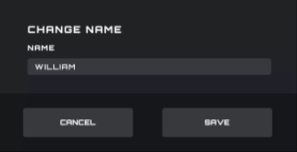
- Edit password
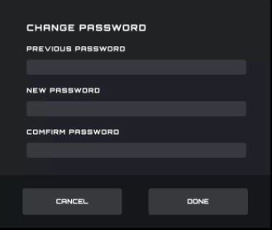
- The old password input box always obscures the password field.
- New password and new password confirmation input field always obscures the password field.
- Click the Cancel button to cancel the modification.
- Click the Done button. After verification, the new password takes effect, and the login interface is opened to log into.
- Back
- Click the Back button to return to the previous interface.

8.4 Setting
Change the setting for G-Menu.
Switch Language
- Displays all currently supported languages, among which the currently used language is highlighted.
- Click the appropriate language button to switch languages immediately.
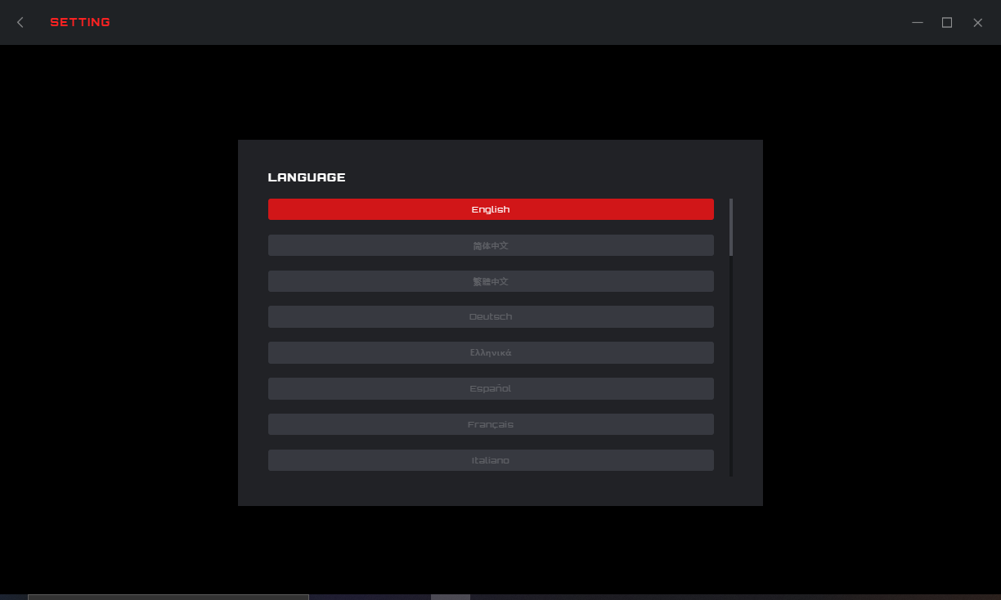 Back
- Click the < (Back) button to return to the previous interface.

8.5 Tray
Exit
- Click the Exit button to exit the application.
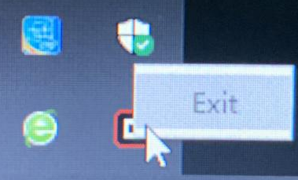

9 Safety Guide and Maintenance
Important
For your safety, please carefully read the following guidelines for the device:
- Do not operate the device under abnormal conditions.
- Avoid looking directly at the device's tracking beam or pointing the beam at anyone's eyes. Please note that the tracking beam is not visible to the naked eye and is set as always-on.
- Do not disassemble the device (this will void the warranty) and do not attempt to operate under abnormal current loads.
- Keep the device away from liquid or moisture. Operate the device only within the indicated temperature range: 0 ° C (32 ° F) to 40 ° C (104 ° F). If the temperature of the device is too high, unplug the device to lower the temperature.
- If the RGB lighting is not running properly, or the device is not functioning, or if there is an abnormal thermal situation, troubleshoot the device by unplugging the device and plugging the device back in .
- If the troubleshooting process does not resolve the issue, unplug the device and visit www.aoc.com for support. Do not attempt to repair the device yourself.

Safety
Federal Communication Commission Interference Statement
This device complies with Part 15 of the FCC Rules. Operation is subject to the following two conditions:
(1) This device may not cause harmful interference.
(2) This device must accept any interference received, including interference that may cause undesired operation.
Note:
This device has been tested and found to comply with the limits for a Class B digital device, pursuant to Part 15 of the FCC Rules. These limits are designed to provide reasonable protection against harmful interference in a residential installation. This device generates, uses, and can radiate radio frequency energy and, if not installed and used in accordance with the instructions, may cause harmful interference to radio communications. However, there is no guarantee that interference will not occur in a particular installation. If this device does cause harmful interference to radio or television reception, which can be determined by turning the equipment off and on, the user is encouraged to try to correct the interference by one or more of the following measures:
—Reorient or relocate the receiving antenna.
—Increase the separation between the device and receiver.
—Connect the device into an outlet on a circuit different from that to which the receiver is connected.
—Consult the dealer or an experienced radio/TV technician for help.



